**FEASIBILITY ANALYSIS**

**INTRODUCTION:**

We are making a software GO-SAFE which is an online cab booking website that allows the users to book a cab and to get sharing from the other customers. This website allows the user to create a user account and it also allows the user to get the information of the available cabs and also can give feedback for the service. We are initially making the payment directly from customer to the driver. Cab sharing can be a most useful feature for the customers for those who don't want to spend that much amount for the distance he travelled.

**BACKGROUND:**

The website will be developed by using HTML , CSS and Bootstrap for the UI .All the features of the service will be easy to use by the user. We are using Heidi SQL to store the database of the website and 000webhosting.com and WAMP server to maintain online servers for the website that will be used to keep updating the cab information. The customer need any operating system with working internet connection can use this software.

**1.TECHNICAL FEASIBILITY :-**

It is a web based software so we need a working pc with working internet connection and a server to maintain the website .The customer need any operating system with working internet connection to use the website. The developer will work under the sever to keep the updates of the available cabs.

**2.OPERATIONAL FEASIBILITY**

The organizational feasibility is the aspect of the feasibility which is important part in implementation of the project. Some of the important aspects include sufficient support for user management, the smooth working of the system for large traffic on website. The new technology needed for this website are low cost but with the increase in data traffic .

**3.ECONOMIC FEASIBILITY :**

Economic Feasibility is one of the important part in the feasibility analysis .In the Economical Feasibility, the cost in developing the website and for maintaining the website are discussed. The cost for making the website and cost for maintaining should be low so that we can get profits for the website.

**4.BEHAVIORAL FEASIBILITY :**

As it is website it works on HTML and CSS so the developers will maintain the website and make easy to understand by the customers. The design is also simple.

**5.PUBLIC RESPONSES :**

Here we have some pie charts of responses that we got from people:-

1. Responses for question 1 :-

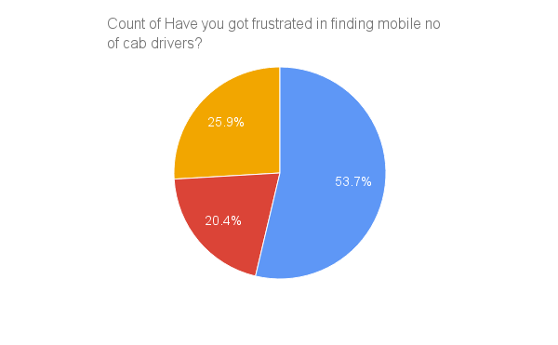

1. Responses for question 2 :-

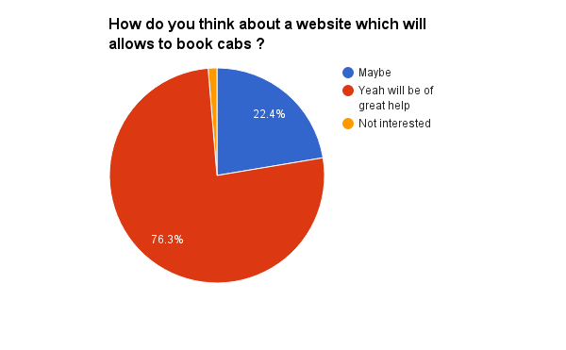

1. Responses for question 3 :-

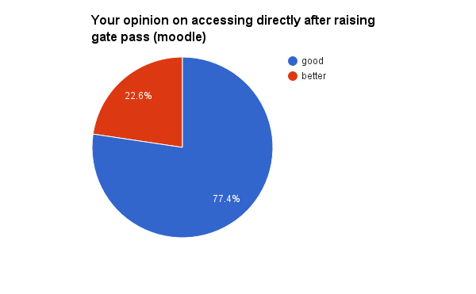

1. Responses for question 4 :-

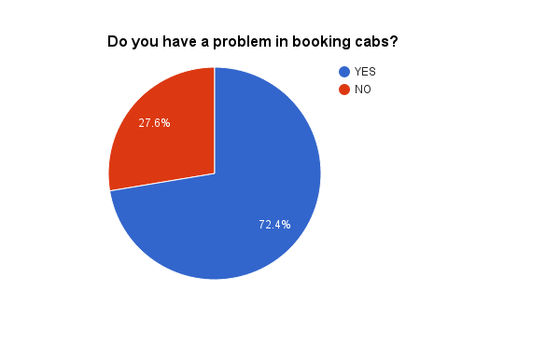

1. Responses for question 5 :-

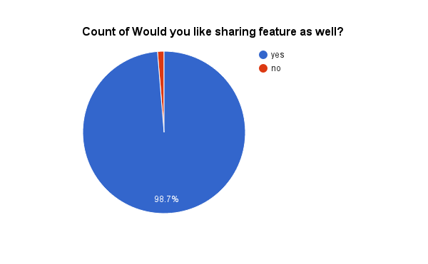

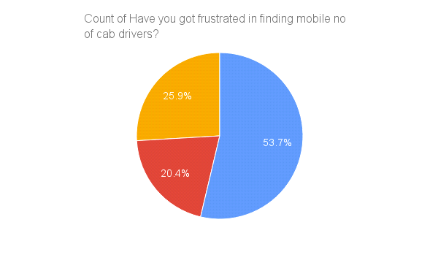

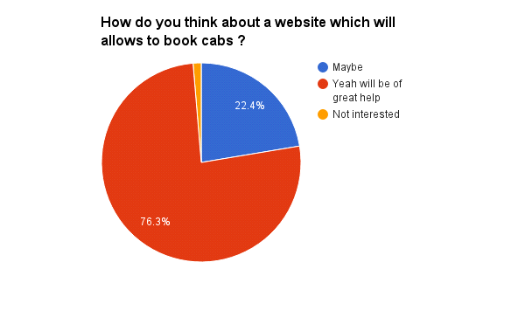

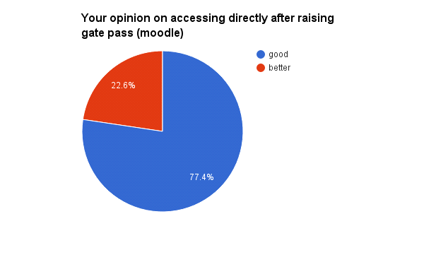**CONCLUSION:**

Since most of the people want the website to be implemented. We are proceeding forward to make the website. The Cab sharing feature will be the most useful feature for most of the customers.